Scenario-Based Requirement Analysis
Software Requirement Specification — Smart Electric Vehicle Charging Network Management Platform
Course: Software Engineering (CSA10 / CSA1063)
Assessment: CO2 Assessment Tool 1 — Scenario-Based Requirement Analysis
CO Assessed: CO2 — Perform requirements analysis, design scalable architectures, and prioritize features

TABLE OF CONTENTS
S.NO | TOPIC | PAGE NO.
1 | SCENARIO UNDERSTANDING AND PROBLEM ANALYSIS | 3-4
2 | FUNCTIONAL AND NON-FUNCTIONAL REQUIREMENTS | 5-6
3 | ACTORS, USE CASES AND USE CASE DIAGRAM | 7-8
4 | SOFTWARE REQUIREMENT SPECIFICATION (SRS) | 9-11
5 | REQUIREMENT MANAGEMENT USING JIRA | 12-13
6 | ASSUMPTIONS AND CONSTRAINTS | 14
7 | REQUIREMENT VALIDATION AND QUALITY REVIEW | 15

1. Scenario Understanding and Problem Analysis

1.1 Business Domain
The project operates in the Smart Mobility / Electric Vehicle (EV) Infrastructure domain, specifically the sub-domain of EV charging network management. This domain sits at the intersection of IoT hardware (charging stations), cloud software platforms, financial technology (digital payments), and urban energy planning, and is experiencing rapid growth as EV adoption accelerates globally and in India.

1.2 Scenario Description
An increasing number of EV owners are finding it difficult to locate, reserve, and pay for charging sessions at public charging stations because existing stations operate as isolated, disconnected units. There is no shared real-time visibility of station availability, no advance booking mechanism, and no unified payment experience across operators. Station operators similarly lack real-time insight into the health of their equipment, and network administrators have no centralized data to guide expansion or load-balancing decisions. The organization commissioning this project wants a single digital platform that connects all three stakeholder groups and resolves these operational gaps.

1.3 Stakeholders
Stakeholder | Interest / Concern
EV Owner | Wants fast, reliable discovery, reservation, and payment for charging sessions.
Charging Station Operator | Wants visibility into station health, usage, and revenue.
Network Administrator | Wants centralized control, analytics, and planning data.
Payment Gateway Provider | Requires secure, standards-compliant transaction integration.
Regulatory / Government Body | Requires compliance with EV charging and data protection standards.
Investors / Business Owners | Want a scalable, profitable, and defensible digital platform.

1.4 Existing Challenges
- No real-time, cross-operator visibility of charging station availability for EV owners.
- No advance reservation mechanism, leading to wasted trips and long queues.
- Fragmented, inconsistent, and often manual payment processes across different station operators.
- No automated fault detection — operators learn about equipment failure from frustrated customers.
- No centralized analytics for administrators to plan network expansion or manage electrical load.
- Poor overall user experience, which discourages EV adoption.

1.5 System Objectives
- Provide real-time station discovery and slot availability to EV owners via a mobile application.
- Enable advance slot reservation to eliminate uncertainty and reduce queuing.
- Automate charging session authentication, monitoring, and billing.
- Provide operators with real-time monitoring and predictive maintenance alerts.
- Provide administrators with usage and revenue analytics to support data-driven decisions.
- Ensure the system is secure, scalable, and reliable enough to support a nationwide charging network.

2. Functional and Non-Functional Requirements

2.1 Functional Requirements
ID | Functional Requirement
FR-01 | The system shall allow an EV owner to register and authenticate using email/phone and password or OTP.
FR-02 | The system shall allow an EV owner to search for charging stations within a specified radius of their location.
FR-03 | The system shall display real-time availability of charging connectors at each station.
FR-04 | The system shall allow an EV owner to reserve a charging slot in advance, with a defined hold period.
FR-05 | The system shall authenticate the EV owner at the charging station via QR code or RFID before starting a session.
FR-06 | The system shall allow the EV owner to start and stop a charging session from the mobile application.
FR-07 | The system shall automatically calculate the charging cost based on energy consumed and applicable tariff.
FR-08 | The system shall process payment through an integrated third-party payment gateway and generate a digital invoice.
FR-09 | The system shall notify the station operator and technician automatically when a fault is detected at a station.
FR-10 | The system shall allow station operators to view and update the status of their charging stations.
FR-11 | The system shall allow administrators to manage user accounts, station onboarding, and pricing configuration.
FR-12 | The system shall generate usage, revenue, and maintenance reports for administrators.

2.2 Non-Functional Requirements
Category | Requirement
Performance | The system shall return station search results within 2 seconds under normal load, for up to 10,000 concurrent users.
Security | All user data, location data, and payment information shall be encrypted in transit (TLS 1.2+) and at rest, with role-based access control.
Reliability | Charging session and payment transactions shall complete correctly even under temporary network interruption, using retry/offline-queue mechanisms.
Usability | The mobile application shall allow a first-time user to complete station search, reservation, and payment within 3 primary screens.
Scalability | The platform shall support horizontal scaling to accommodate growth from hundreds to tens of thousands of charging stations.
Maintainability | The system shall be built as independent microservices so that individual modules can be updated without affecting others.
Availability | The platform shall target 99.9% uptime, given its role in daily commuter mobility.
Interoperability | The system shall support multiple connector standards and integrate with third-party mapping and payment services via REST APIs.

3. Actors, Use Cases, and Use Case Diagram

3.1 Primary and Secondary Actors
Actor | Type | Description
EV Owner | Primary | Registers, searches for stations, reserves slots, charges, and pays.
Station Operator | Primary | Manages and monitors assigned charging stations.
System Administrator | Primary | Manages platform-wide configuration, users, and analytics.
Payment Gateway | Secondary (External) | Processes and confirms digital payment transactions.
Maintenance Technician | Secondary | Responds to fault alerts and repairs charging stations.

3.2 Major Use Cases by Actor
- EV Owner: Register/Login, Search Nearby Stations, View Real-time Availability, Reserve Charging Slot, Authenticate at Station, Start/Stop Charging Session, Make Payment, View Charging History.
- Station Operator: Monitor Station Status, Update Station Information, Receive Maintenance Alerts, View Station Revenue Report.
- System Administrator: Manage Users, Onboard New Stations, Configure Pricing, Generate Network Analytics Reports.
- Payment Gateway (external): Authorize Payment, Confirm Transaction.
- Maintenance Technician: Receive Fault Ticket, Update Repair Status.

3.3 Use Case Diagram
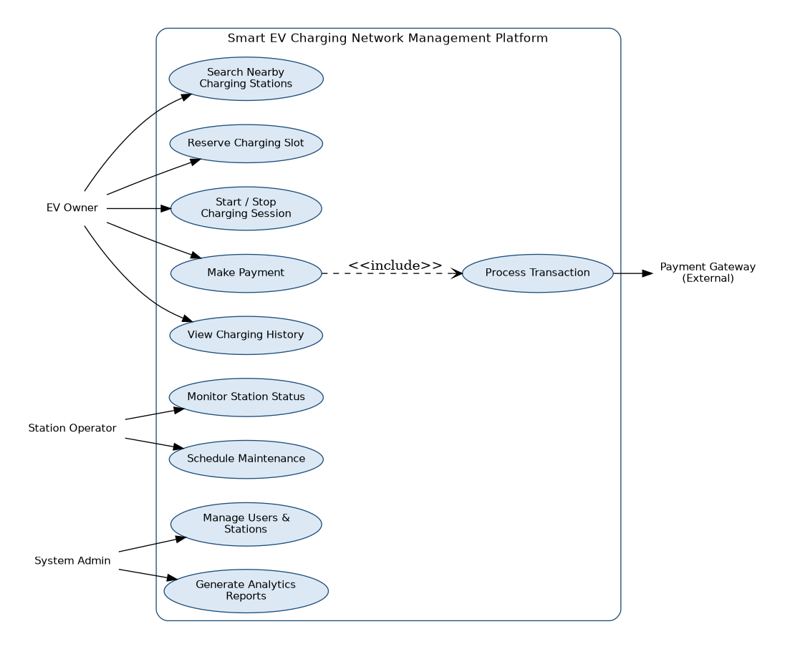
Figure 3.1: Use Case Diagram — Smart EV Charging Network Management Platform

4. Software Requirement Specification (SRS)

4.1 Introduction
This Software Requirement Specification (SRS) document describes the functional and non-functional requirements of the Smart EV Charging Network Management Platform. It is intended for use by the development team, project stakeholders, and evaluators to establish a shared, unambiguous understanding of what the system must do.

4.2 Problem Description
EV charging today is fragmented across independent operators with no shared visibility, no reservation capability, and inconsistent payment processes, resulting in a poor experience for EV owners and limited operational insight for operators and administrators. The system described in this SRS addresses that gap through a unified, cloud-connected software platform.

4.3 Scope of the System
The scope covers the software platform that manages station discovery, slot reservation, charging session authentication and monitoring, payment processing, fault alerting, and analytics reporting. It includes the EV owner mobile application, the operator/administrator web dashboard, and the backend cloud services that connect to IoT-enabled charging stations. It excludes the physical/electrical design of charging hardware and the civil infrastructure for station installation, which are treated as external systems.

4.4 Functional Requirements
Refer to Section 2.1 (Functional Requirements table, FR-01 to FR-12) for the complete list of functional requirements considered part of this SRS.

4.5 Non-Functional Requirements
Refer to Section 2.2 (Non-Functional Requirements table) for performance, security, reliability, usability, scalability, maintainability, and availability requirements.

4.6 Use Case Descriptions
Field | UC-01: Reserve Charging Slot
Actor | EV Owner
Description | Allows an EV owner to reserve an available charging slot at a chosen station in advance.
Precondition | EV owner is registered, logged in, and has selected a station with an available slot.
Main Flow | 1) Owner selects a station and available time slot. 2) Owner confirms reservation. 3) System holds the slot for 15 minutes. 4) System sends confirmation notification.
Postcondition | The slot is reserved and blocked from other users until the hold expires or the session starts.

Field | UC-02: Authenticate and Start Charging Session
Actor | EV Owner
Description | Allows an EV owner to authenticate at the physical station and begin a charging session.
Precondition | Owner has an active reservation and is physically present at the station.
Main Flow | 1) Owner scans QR code or taps RFID card. 2) System verifies identity and reservation. 3) System unlocks the connector. 4) Owner starts the session from the app.
Postcondition | A charging session is active and energy consumption is being metered.

Field | UC-03: Process Payment
Actor | EV Owner, Payment Gateway
Description | Calculates the cost of a completed charging session and processes payment.
Precondition | A charging session has ended.
Main Flow | 1) System calculates cost from energy consumed and tariff. 2) Owner confirms payment. 3) System sends the request to the payment gateway. 4) Gateway confirms transaction. 5) System generates a digital invoice.
Postcondition | Payment is completed and an invoice is available to the owner.

Field | UC-04: Monitor Station and Receive Fault Alert
Actor | Station Operator, Maintenance Technician
Description | Allows an operator to monitor live station status and be alerted automatically to faults.
Precondition | The station is online and reporting telemetry to the cloud.
Main Flow | 1) Station sends periodic telemetry. 2) System detects an abnormal reading. 3) System raises a fault alert to the operator and technician. 4) Technician updates repair status.
Postcondition | The fault is logged, and the responsible parties are notified.

4.7 Data Requirements
- User data: user ID, name, contact details, credentials, role (owner/operator/admin).
- Vehicle data: vehicle ID, model, battery capacity, connector type.
- Station data: station ID, location (latitude/longitude), connector types, operational status.
- Booking data: booking ID, user ID, station/connector ID, start/end time, status.
- Session data: session ID, booking ID, energy consumed (kWh), start/end timestamps.
- Payment data: payment ID, session ID, amount, payment status, timestamp.
- Telemetry data: station ID, sensor readings, timestamp — stored in a time-series store for analytics and fault detection.

4.8 External Interface Requirements
- User Interface: a native mobile application (Android/iOS) for EV owners, and a responsive web dashboard for operators and administrators.
- Hardware Interface: IoT communication (e.g., MQTT) between charging station controllers and the cloud backend.
- Software Interface: REST API integration with a third-party payment gateway and a mapping/geolocation service.
- Communication Interface: HTTPS/TLS for all client-server communication; push notification service for alerts.

4.9 System Features
- Real-time station search and map-based discovery.
- Advance slot reservation with automatic hold and release.
- QR/RFID-based secure session authentication.
- Automated cost calculation and digital payment.
- Real-time fault detection and maintenance alerting.
- Centralized analytics dashboard for administrators.

5. Requirement Management Using Jira
To manage, track, and prioritize the requirements identified in this analysis, the requirements and their corresponding user stories were logged as issues in Jira Software under the project key EVCP (Smart EV Charging Network Management Platform). Each functional requirement was converted into a trackable issue (Story, Epic, or Bug) with a story point estimate, an assignee, and a status, allowing the requirement set to be prioritized, planned into sprints, and monitored through to completion — rather than existing only as static text in a document.

5.1 Product Backlog in Jira
The Jira Backlog view below shows the requirements organized into the active Sprint 1 (the highest-priority, foundational requirements) and the remaining Product Backlog, each tagged with a story-point estimate and current status. This gives the requirement set the traceability and prioritization that a plain SRS document alone cannot provide.
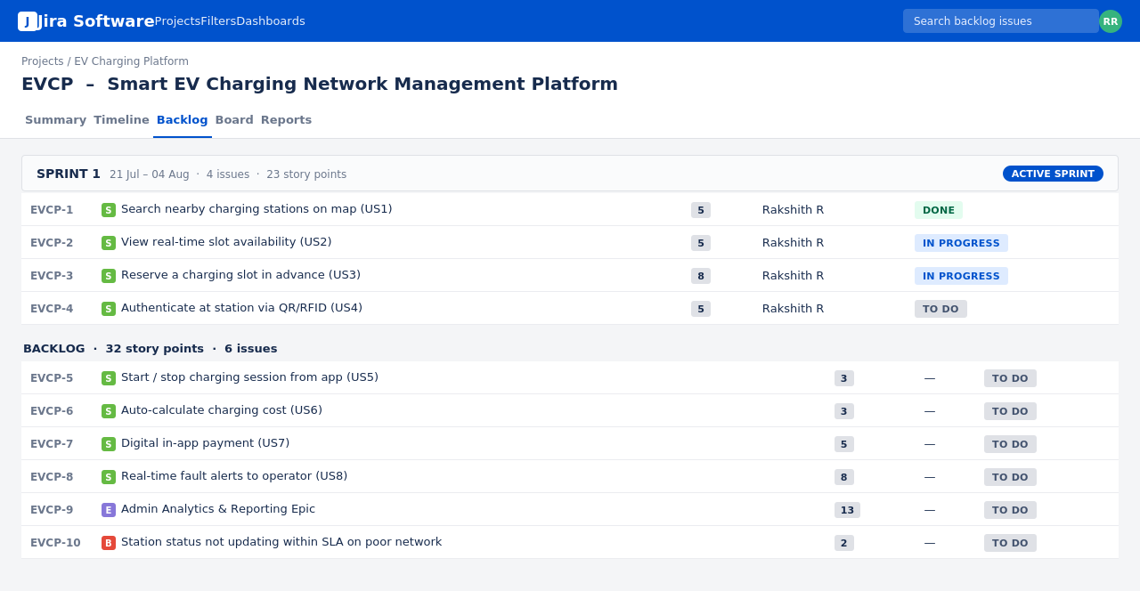
Figure 5.1: Jira Backlog View — EVCP Project Requirements

5.2 Sprint Board in Jira
The Jira Board view below tracks the real-time progress of Sprint 1's committed requirements across To Do, In Progress, In Review, and Done columns, giving the team and stakeholders continuous visibility into requirement delivery status.
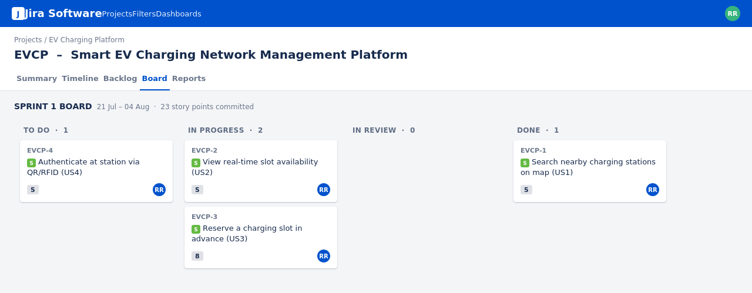
Figure 5.2: Jira Sprint Board — Sprint 1 Requirement Tracking

5.3 Benefits of Using Jira for This Analysis
- Traceability: every functional requirement (FR-01 to FR-12) maps directly to a trackable Jira issue (e.g., EVCP-1 to EVCP-10), so progress on each requirement can be verified at any time.
- Prioritization: Jira's backlog ordering made it straightforward to apply the MoSCoW/value-based prioritization from the sprint planning phase directly to requirement delivery order.
- Visibility: stakeholders (operators, administrators) can view real-time status of requirement implementation without needing to re-read the SRS document.
- Change management: as new requirements or clarifications emerge, they can be added as new issues and re-prioritized without disrupting the existing document structure.
- Integration: Jira supports linking requirements to test cases, code commits, and sprint reports, enabling full requirement-to-delivery traceability in later phases of the project.

6. Assumptions and Constraints

6.1 Assumptions
- EV owners have smartphones with internet connectivity and GPS capability.
- Charging stations are equipped with, or can be retrofitted with, IoT connectivity modules.
- A reliable third-party payment gateway is available for integration.
- Station operators are willing to share real-time status data with the platform.
- Mobile network coverage is generally available at or near charging station locations.

6.2 Constraints
Type | Constraint
Technical | The system must integrate with charging hardware from multiple manufacturers using varying communication protocols.
Operational | 24/7 availability is required since EV charging needs can arise at any time.
Economic | Development and cloud infrastructure costs must remain within the project's allocated budget, favouring managed cloud services over custom infrastructure.
Legal / Regulatory | The system must comply with applicable data protection regulations and regional EV charging standards.
Time | The system must be delivered incrementally within fixed sprint cycles to meet the project's academic/delivery timeline.

7. Requirement Validation and Quality Review

7.1 Completeness Check
Each stakeholder group identified in Section 1.3 has at least one corresponding functional requirement and use case: EV owners are covered by FR-01 to FR-08, station operators by FR-09 to FR-10, and administrators by FR-11 to FR-12. Non-functional requirements address performance, security, reliability, usability, scalability, maintainability, and availability, covering all categories specified in the assignment brief.

7.2 Consistency and Ambiguity Check
- No contradictory requirements were identified — e.g., the requirement for offline-tolerant payment retry (NFR-Reliability) does not conflict with the 2-second response requirement (NFR-Performance), since retries apply only under network failure conditions.
- Requirement wording was reviewed to remove ambiguous terms (e.g., 'fast', 'user-friendly') in favour of measurable criteria (e.g., '2 seconds', '3 primary screens'), consistent with the acceptance criteria defined in the related Agile Sprint Planning workshop.
- No duplicate requirements were found; each functional requirement maps to exactly one Jira issue and one use case.

7.3 Suggested Improvements
- Add a formal requirement traceability matrix linking each FR/NFR to its corresponding use case, Jira issue, and test case for full lifecycle traceability.
- Conduct a stakeholder review workshop to validate assumptions (e.g., IoT retrofit feasibility) before committing to the technical design.
- Define explicit service-level agreements (SLAs) for fault-alert response time and payment gateway settlement time.
- Introduce a formal change-request process in Jira to manage scope changes without destabilizing the current sprint commitments.
Overall, the requirement set developed through this scenario-based analysis is judged to be complete, consistent, and directly traceable to both the identified stakeholders and the Jira-managed backlog, providing a solid foundation for the subsequent design and development phases of the Smart EV Charging Network Management Platform.

